CONSTELLATION – EVENT SCHEDULING
2024 04 22

Attendees:
- Global Technology:
  - Kristen Baum: Sr. Product Manager
    - Product Manager for the UXP project, leading the meeting
  - Luis Bustos: Director, Technology Architect & Strategy
    - Data Architect for the UXP project, explaining the features and integrations
- Amex Team:
  - April Garrett: VP Group Director Business Leaders
    - From the BL side, involved in the project.

CONSTELLATION BRANDS Account Teams
- Corona Premier, a light beer that has hoops and summer programs.
- Corona Extra, a Mexican lager that is part of the same portfolio as Corona Premier.
- Modelo Especial, a pilsner-style lager that has Modelo Custom Shop, a 24 market on premise activation that involves block printing and local artists.
- Pacifico, a pilsner-style beer that they do not currently do any activations for.

Momentum structures
- Field Team: Organized by business unit to mirror the client structure, ensuring a seamless extension of the client teams. They manage scheduling with local clients and handle direct interactions during events.
- BL Team: Works on creative concepts and tactical tools necessary for executing events. This team also manages interactions with trade marketing clients.
- Production Team: Responsible for custom builds and logistics like managing traveling vans for tours (such as the Modelo Custom Shop program). They also handle the logistical aspects of events, including shipments and equipment.
- Strategy and Creative Team: Flex in and out as needed, contributing to the creative process throughout the year.

Staffing Events with Brand Ambassadors
- Recruitment and Training:
  - Hiring: Approximately 200 brand ambassadors are recruited through the staffing agency "Hype" to manage the events effectively across various locations.
  - Training: Brand ambassadors receive training to align with the specific requirements of each brand and event, ensuring consistency and quality in customer interactions and brand representation.
- Role of Brand Ambassadors:
  - Event Execution: They are responsible for engaging with attendees, delivering the brand message, and managing on-site event activities.
  - Feedback Collection: Gather and report attendee feedback to improve future events and adjust strategies as needed.

Management of One-Off Projects
- Special Projects: Occasionally, one-off projects with unique requirements and timelines are initiated, requiring tailored approaches.
  - Project-Specific Teams: These projects often involve forming teams that can handle unique challenges and meet specific goals set for the project.
  - Flexible Timelines and Goals: Unlike regular events, these projects may have variable timelines and objectives that demand adaptability and specialized planning.

Client structures
- Clients are segmented based on the sales territory, which dictates the organization of the field teams. This segmentation aligns with how the country is divided from a sales perspective.
- Trade marketing clients are involved in approving the program concepts and the number of events, which are then executed with the support of the field and BL teams.
- The field team's interactions with clients are crucial for the execution of the events, as they communicate directly with the bars, restaurants, or event spaces where activations take place.
Complexity Management
  - Events involve multiple aspects such as logistics, creative content, client interactions, and compliance with marketing strategies.
  - Managing these complexities requires a well-orchestrated effort between various specialized teams.
Team Coordination
  - Field Team: Ensures that each event is scheduled and executed according to plan, maintaining direct communication with clients on the ground.
  - BL Team: Coordinates with trade marketing clients to develop event concepts and ensure tactical tools are prepared and relevant for each event.
  - Production Team: Handles the physical aspects of events, including setups, custom builds, and the logistical movement of materials and equipment.
  - Strategy and Creative Team: Provides overarching creative direction and strategic alignment to ensure that events meet brand objectives and engage target audiences effectively.
Client-Specific Needs
  - Each client may have unique demands based on the market segment, geographic location, and strategic importance.
  - Customization of events to fit these unique demands ensures client satisfaction and the effectiveness of the marketing efforts.
Strategic Objectives:
  - Events are designed to achieve specific marketing goals which could include brand awareness, product launches, customer engagement, or direct sales.
  - The coordination among teams ensures that each event not only meets operational standards but also aligns with broader marketing strategies to drive these goals.
Feedback and Adaptation:
  - Continuous feedback loops between the teams and with clients help refine and improve the event planning and execution process.
  - Adaptation to new information or changing market conditions is facilitated by this tight coordination, allowing the team to be agile and responsive.
Technology and Tools:
- Google Docs:
  - Primary Tool: Utilized extensively for collaborative planning and real-time document sharing among teams.
  - Functionality: Allows multiple users to access, update, and manage documents simultaneously, ensuring all team members have the latest information.
  - Documentation: Used for creating event schedules, checklists, and gathering feedback from multiple stakeholders.
- Google Slides Usage:
  - Collaborative Tool: Google Slides serves as a central platform for creating, sharing, and editing slide decks in real-time by multiple users across different locations.
  - Team Contributions: Allows for seamless collaboration where team members can add content, provide feedback, and make edits simultaneously.
  - Role Specification:
    - Content Creators: Typically, members from the creative and BL teams who design the visual and content aspects of the presentations.
    - Data Analysts: Input relevant data findings to enhance the presentations with actionable insights, where applicable.
    - Project Managers: Oversee the slide deck's progress, ensuring all sections are completed on time and meet the required standards.
    - Operations Staff: Update logistical and operational details that are critical for event execution.

Activation Duration
- 72-Week Activation Cycle:
  - Long-Term Planning: The extended duration of activations requires meticulous long-term planning and continuous monitoring.
  - Scheduling Complexity: Managing such a long activation timeline involves coordinating numerous logistics, staffing, and marketing activities over an extended period.
Operations and Management
- Lack of Project Management (PM) and Analytics:
  - No Dedicated PM Role: The team operates without a specialized project manager, placing greater emphasis on individual team members to manage their segments of projects.
  - Limited Analytics Capability: The absence of a dedicated analytics function means the team relies on basic data collection and analysis, potentially impacting the strategic decision-making process.
Operations Personnel:
  - Role and Responsibilities: An operations person bridges gaps between different functional areas, ensuring smooth execution and operational efficiency.
  - Process Improvement: Tasked with implementing or developing new processes that enhance operational flow and efficiency at events.
  - Support and Coordination: Provides essential support to both field and BL teams, helping to coordinate tasks and ensure that all operational aspects run smoothly.

Process workflow:
- Data Collection:
  - Event Execution: Data is gathered from events executed across various locations. This includes data on attendance, engagement metrics, and specific activities conducted at each event.
  - Client Interactions: Information from interactions with clients and venues, such as feedback and specific requests, is also collected to tailor future events.
- Data Entry:
  - Manual Input: Data from events and client feedback are manually entered into various systems such as Main Event or Google Sheets.
  - Automated Systems: Some data is automatically captured through digital tools used during the events, such as QR code scanners or digital registration forms.
- Data Integration and Management:
  - Multiple Platforms: Data is managed across different platforms, which are not fully integrated. This includes CRM systems, custom event management software, and spreadsheets.
  - Real-Time Access and Updates: April emphasized the importance of having real-time access to data to make on-the-fly decisions and adjustments during events.
- Data Reporting:
  - Internal Reports: Data is compiled into internal reports for team reviews. These reports are used to assess event performance and plan future activities.
  - Client Reports: Data is also formatted into reports for clients, showing the success and reach of events. These are more polished and often include visual elements and detailed analytics.
  - Post-Event Analysis: After events, data is analyzed to measure success against pre-set objectives and to gather insights for future improvements.
- Feedback Loop:
  - Continuous Improvement: Insights gained from data analysis are used to improve future events. This includes refining event strategies, enhancing client interaction protocols, and improving logistical arrangements.
  - Team Collaboration: Data and insights are shared across teams to ensure all stakeholders are informed and can contribute to the continuous improvement process.
Data Process
Brand Management:
- Brands: April is responsible for managing activations for four brands owned by Constellation: Corona Premier, Corona Extra, Modelo Especial, and Pacifico.
- Activation Settings: The primary focus of these activations is on-premise events in bars and restaurants, tailored to enhance brand visibility and customer engagement in target demographics.
Event Types and Programs:
- Modelo Custom Shop: This program features bespoke, brand-themed installations in select venues, providing a unique experience that aligns with the brand’s image.
- Corona Premier Hoops and Summer Programs: These seasonal events capitalize on peak periods such as summer and sports seasons to engage consumers with themed activities.
- Corona Extra LGBTQIA+ Programs: Targeted events that support and celebrate the LGBTQIA+ community, fostering brand inclusivity and community engagement.
Team Structure and Roles:
- Field Team:
  - Configuration: Organized by business units mirroring client structures to ensure localized and effective event management.
  - Responsibilities: Manages direct scheduling of events with local clients and ensures the execution aligns with the strategic brand objectives.
- Brand Leadership (BL) Team:
  - Role: Develops creative concepts and designs tactical tools necessary for executing memorable events that resonate with attendees.
  - Collaboration: Works closely with the field team to ensure that event themes and materials align perfectly with the overall brand strategy.
- Production Team:
  - Logistics Management: Oversees the sourcing, assembly, and disassembly of custom builds specific to each event.
  - Tour Management: Manages tour managers who coordinate the logistics of traveling displays or exhibits, particularly for Modelo Custom Shop.
  - Freight and Shipping: Handles all aspects of transportation logistics to ensure event materials arrive safely and on time.
- Operations Support:
  - Integration Role: Provides critical support bridging the field and BL teams, ensuring seamless communication and implementation of processes.
  - Process Development: Innovates and refines operational processes to enhance efficiency and effectiveness across events.
Implementation and Strategy:
- Process Innovation: April emphasizes the importance of continually developing new processes to keep the operational aspects of events fresh and effective.
- Cross-Functional Collaboration: Ensures close collaboration among all teams to leverage creative ideas and logistical capabilities, optimizing the impact of each event.

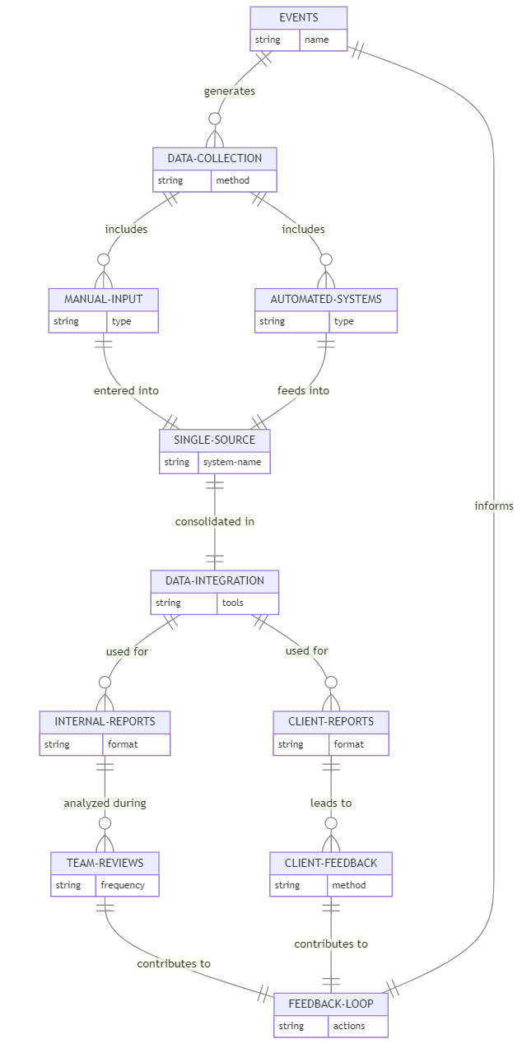

April's Feedback
- Challenges and Pain Points:
  - Manual Processes: Reliance on manual inputs leads to inefficiencies and potential errors.
  - Multiple Systems: Difficulty using and integrating multiple platforms complicates management and tracking.
  - Data Access and Visibility: Concerns about limited access to real-time data affecting decision-making.
- Proposed Improvements:
  - System Integration: Enhance integration to reduce redundancy and improve operations.
  - User-Friendly Interfaces: Develop more intuitive interfaces to ease navigation and usage of tools.
  - Enhanced Reporting Features: Improve reporting functionalities to offer deeper insights and detailed analytics.
- Importance of Real-Time Data:
  - Implement features that allow immediate access to updated data, facilitating agile responses to challenges during events.
- Client-Specific Customization:
  - Tailor event management approaches to meet diverse client requirements and preferences.
Reporting Requirements:
- Reporting and Analytics:
  - Weekly/Monthly Event Overview: Develop functionality within the system to view the number of events executed on a regular basis.
  - Market Distribution Analytics: Implement features to visualize event distribution across markets.
  - Engagement Metrics: Integrate tools to track and assess engagement objectives at events.
  - Sampling Objectives: Develop a system to measure and report the achievement of sampling goals.
- Client Reporting:
  - Client-Friendly Reports: Design and implement modules for generating visually appealing reports directly from event data.
  - Customizable Templates: Provide templates that can be customized to align with client branding and preferences.
- Data Visualization and Access:
  - Dashboard Development: Create a real-time dashboard with instant access to all metrics.
  - Interactive Features: Enhance data visualization with interactive graphs, pie charts, and heat maps.
- Training and Support:
  - User Training: Conduct training sessions for April and her team to effectively use new tools.
  - Ongoing Support: Provide continuous technical support and gather feedback for improvements.
- Feedback Integration and Continuous Improvement:
  - Feedback Mechanism: Establish a feedback loop to continuously collect insights on tool utility and needed enhancements.
  - Iterative Development: Utilize feedback to make ongoing improvements to the analytics and reporting functionalities.

Requirements table:
Overarching Theme | Category | Item | Requester | MVP | v1+ | Not in scope | Complexity
Data Visualization | Reporting | Weekly/Monthly Event Overview | April | ✔ |  |  | Medium
Data Visualization | Analytics | Market Distribution Analytics | April | ✔ |  |  | Medium
Performance Metrics | Engagement Tracking | Engagement and Sampling Objectives Metrics | April | ✔ |  |  | High
Client Reporting | Aesthetic Reporting | Development of Client-Friendly Report Generation | April |  | ✔ |  | High
Client Reporting | Customization | Customizable Reporting Templates | April |  | ✔ |  | Medium
Real-Time Data Access | Dashboard Development | Real-Time Access Dashboard with Interactive Features | April |  | ✔ |  | High
Training | User Training | Training on New Reporting Tools | April | ✔ |  |  | Medium
Support and Feedback | Technical Support | Ongoing Technical Support and Feedback Mechanism | April | ✔ |  |  | Low
Continuous Improvement | Feedback Implementation | Continuous Improvement Based on Feedback | April |  | ✔ |  | Medium

Files and data shared post-meeting
- Market Event Recap (example)
- National Program Recap (example)
- Market Schedule Google Doc (example)
- Main Event Login for luis.bustos@momentumww.com
  - Website: https://global.constellationbeerbrands.networkninja.com
  - Username: lbustos
  - Password: Enter your username, click “Continue to Site”, click “Lost Password”, type your Momentum email to reset your password.

